Mini Network Simulator with Java
  - Specification and Reference

UDP
For a great guide on UDP click here.
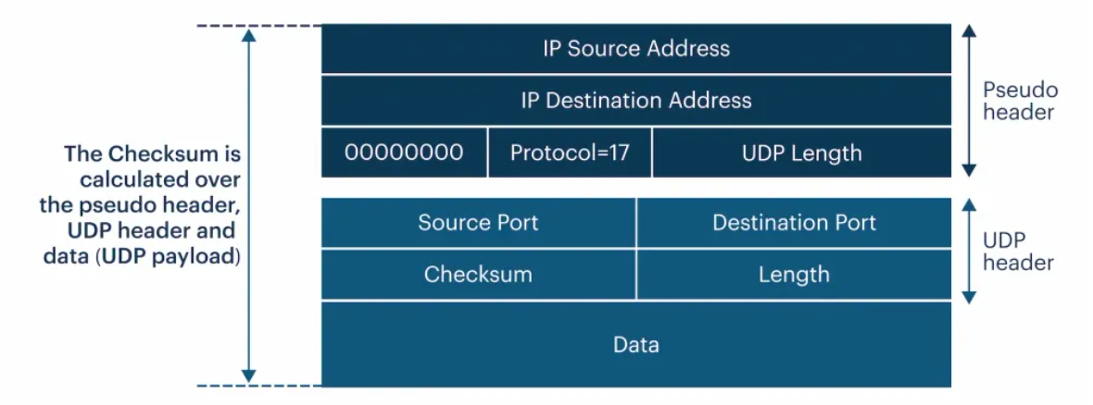
Ports:
- Well-Known Ports (0-1023): Reserved for standard protocols like DNS (port 53), DHCP (ports 67/68), and NTP (port 123).
- Registered Ports (1024-49151): Assigned for specific services or applications. – we’ll assign these
- Dynamic/Private Ports (49152-65535): Used temporarily by applications for short-lived connections, often for internal communication.

IP Layer Handoff & Link Layer Encapsulation
UDP is passed to the IP layer, which adds its own header containing source and derstination IP addresses. This enables the UDP packet to be routed tot he correct destination over the network. The IP layer is responsible for packet routing and once the IP header is adderd, the entire packet is encapsulated into a link-layer frame (Ethernet/Wi-fi) for transmission over the physical network. This allows the data to travel across various routers and network segments on its way to the destination.

UDP Layer Processing & Reception
Upon reaching the destination the IP header is removed and the UDP datagram is extracted. The recipient’s UDP layer verifies the checksum (if used) to ensure the integrity of the transmitted data. It then uses the destinatino port in the UDP header to identify the correct application to forward the data. Since UDP doesn’t guarantee delivery or ordering of packets it is up to the application to handle retransmission or other recovery mechanisms if needed. Once processed, the data is extracted from the UDP datagram and passed to the target application for further handling.

Applications on different transport layer protocols
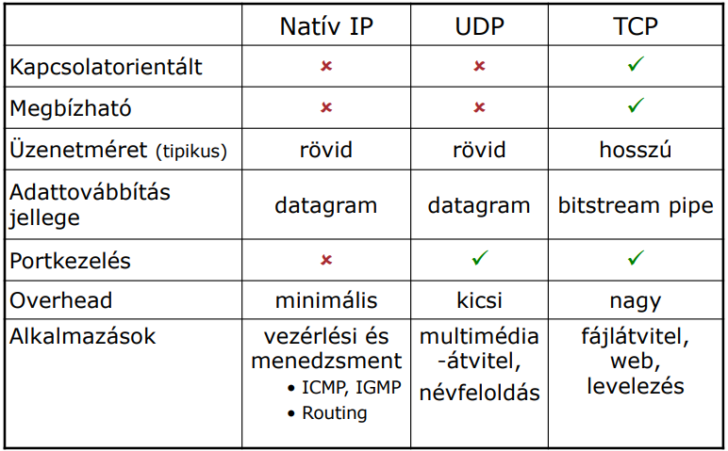

IP Protocoll field values over Native IP
Control:
- ICMP
Routing
- 89 OSPF (Open Shortest Path First)
Real Transport Layer Protocols
- 6 TCP
- 17 UDP

Services using portnumbers over UDP

Serverside Portnumber Values
- 53 DNS
- 67 BOOTP/DHCP (Server side)
- 68 DHCP (Client side)
- 520 RIP (Routing Information Protocol)

Services and Protocols using portnumbers over TCP

Serverside Portnumber Values
- 20-21 FTP
- 22 SSH
- 23 Telnet
- 25 SMTP (Simple Mail Transfer Protocol)
- 53 DNS
- 80 HTTP
- 110 POP3 (Post Office Protocol version 3)
- 143 IMAP4 (Internet Message Access Protocol version 4)
- 443 HTTPS
- 465 SMTPS
- 993 IMAP4S
- 995 POP3Sű

DHCP

DHCP Messages

Discover
From 0.0.0.0 to 255.255.255.255

Offer
to 255.255.255.255 from DHCP server address
- Offered IP address
- Subnet Mask
- Lease timeframe
- DHCP Server address
- MAC address of the device that requested an IP

Request
From 0.0.0.0 to 255.255.255.255 or to the DHCP server address message contents
- The Endpoint requests one of the offers to be assigned to them
- Transaction ID (which DHCP server gave the offer)
- Requested IP
- DHCP Server address

Acknowledge
From DHCP server address to broadcast
Message contents
- the distributed IP
- subnet mask
- lease timeframe

Packets, Protocols and their headers in protocols
Refer to each (useful for our implementation) field in each protocol
Have a common protocol class
- this way we can have all protocols in a universal list
- this way each message can be universal, and there will be additional space in packets to have pure data as well
- protocols that have other protocols layered into them can this way refer to the specific parameters of that layered in protocol
Packet class
- has a header segment
- has a data segment

